PIGEON GUILLEMOT
BREEDING SURVEY
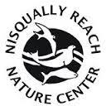
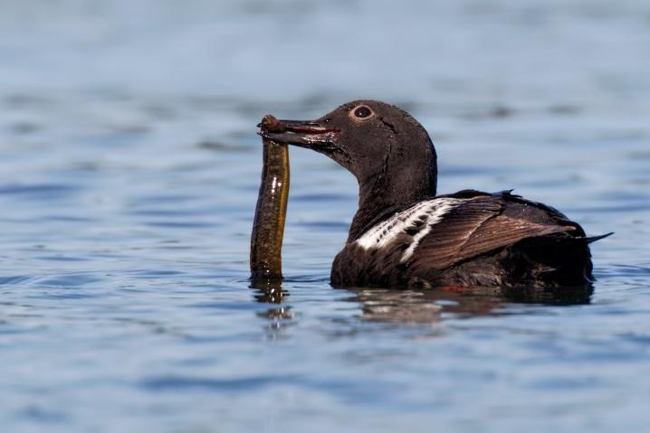

Nisqually Reach Nature Center
(360) 459-0387
nrnc@nisquallyestuary.org
---------------------------------------
Anne Mills: (360) 888-9417, pigu@nisquallyestuary.org
Terence Lee: (360) 556-2738, pigu@nisquallyestuary.org

